Exercises Fifth Grouping (Fgrep Command)

*Task #1*

cat password.txt

• Was that a fun file to watch go by?

• Its Big

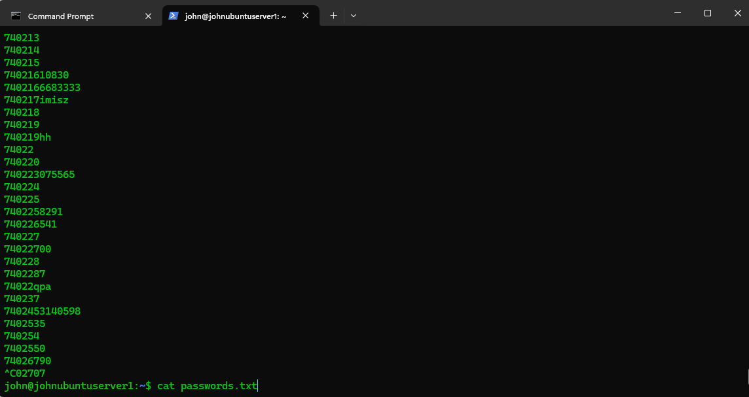

*Task #2*

less password.txt

• Its Big

• When your bored of checking it out

• Hit q to quit

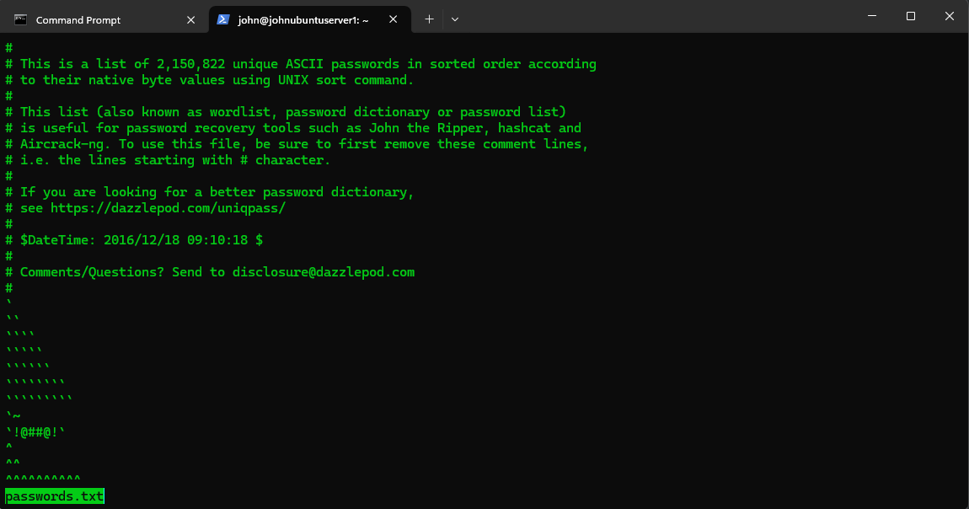

*Task #3*

fgrep "123456" passwords.txt

• What did that do?

• Explain what just happened.

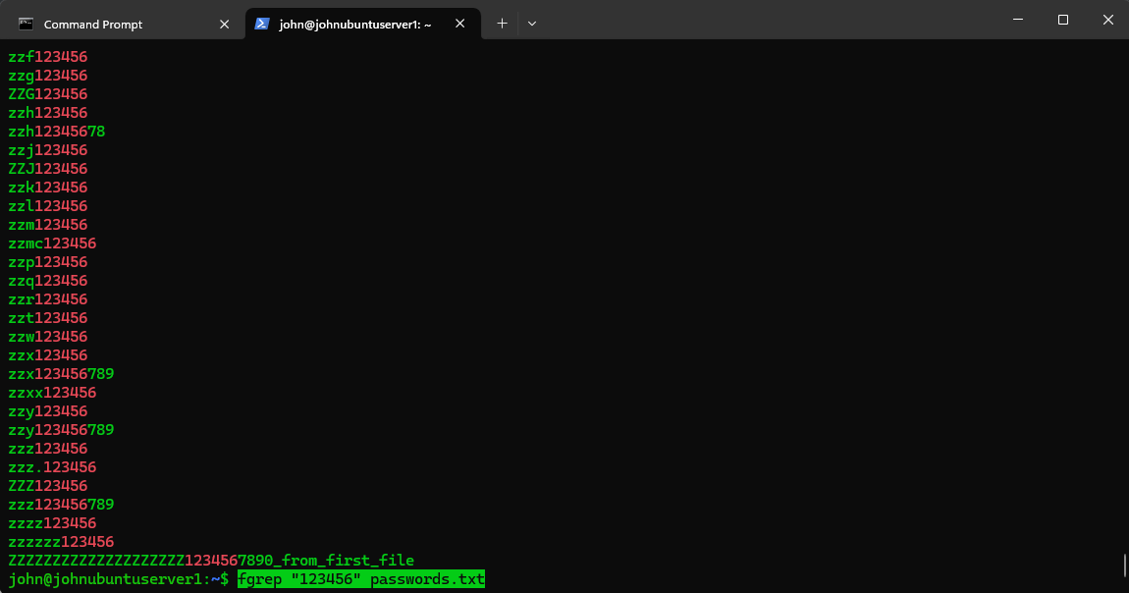

1. **fgrep:** This is a command-line utility that searches for a specific string of text in files. The "f" in **fgrep** stands for "fixed," meaning it searches for exact matches of the string specified.
2. **"123456":** This is the string being searched for. In this case, it's the sequence of characters "123456".
3. **passwords.txt:** This is the file in which the search is being conducted. In this case, it's a file named "passwords.txt".

**Explanation of what happened:**

When the command is executed, **fgrep** searches through the contents of the file **passwords.txt** for the exact string "123456". If any lines in the file contain this exact sequence of characters, **fgrep** will display those lines on the terminal.

In summary, the command searched for occurrences of "123456" within the file **passwords.txt** and displayed any lines containing this exact sequence of characters. This could be used in various scenarios such as finding passwords stored in a plaintext file.

*Task #1*

vim passwords.txt

• Add “1234567890_from_first_file” to the end of the file after the zzz not a new line.

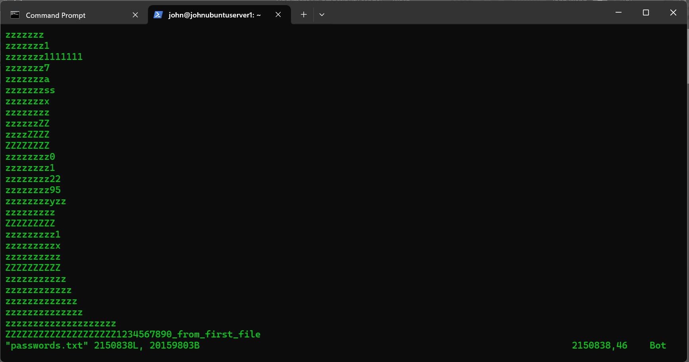

*Task #2*

• Create a copy of the first file, as passwords2.txt

• Edit the second file.

o Change the last line to “1234567890_from_second_file”

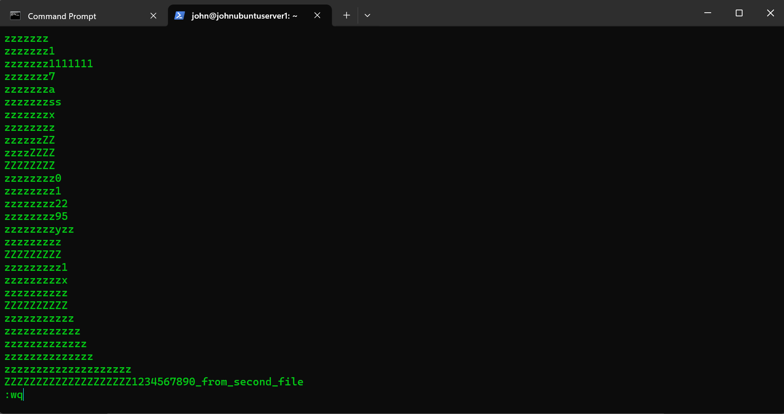

*Task #3*

fgrep 1234567890_ passw*

• What did that do?

• Explain what just happened.

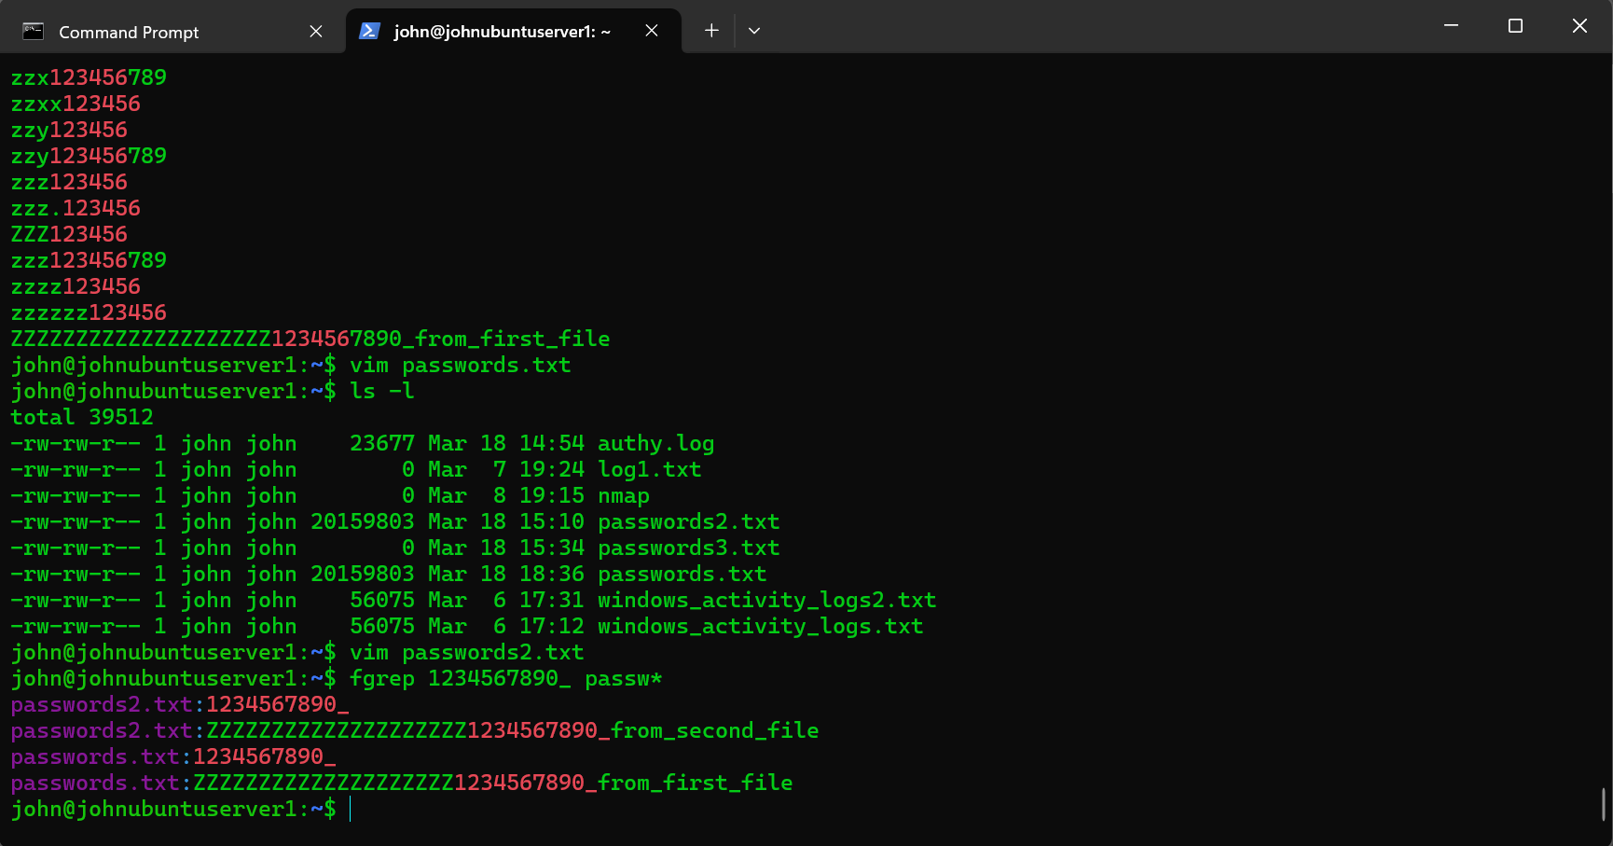

1. **fgrep:** This is a command-line utility that searches for a specific string of text in files. The "f" in **fgrep** stands for "fixed," meaning it searches for exact matches of the string specified.
2. **1234567890_:** This is the string being searched for. In this case, it's the sequence of characters "1234567890_".
3. **passw*:** This is a wildcard expression used to specify the file or files in which the search is conducted. The asterisk (*) is a wildcard character that matches any sequence of characters. So **passw\*** would match any files starting with "passw".

**Explanation of what happened:**

When the command is executed, **fgrep** searches through the contents of all files in the current directory that match the pattern **passw\*** for the exact string "1234567890_". If any lines in any of those files contain this exact sequence of characters, **fgrep** will display those lines on the terminal.

In summary, the command searched for occurrences of "1234567890_" within files whose names start with "passw" in the current directory, and displayed any lines containing this exact sequence of characters. This command could be used to search for specific patterns within multiple files, such as searching for a specific string in multiple password files.

Exercise 18

*Task #1*

fgrep 1234567890_ passwords.txt > passwords3.txt

• What did that do?

• Explain what just happened.

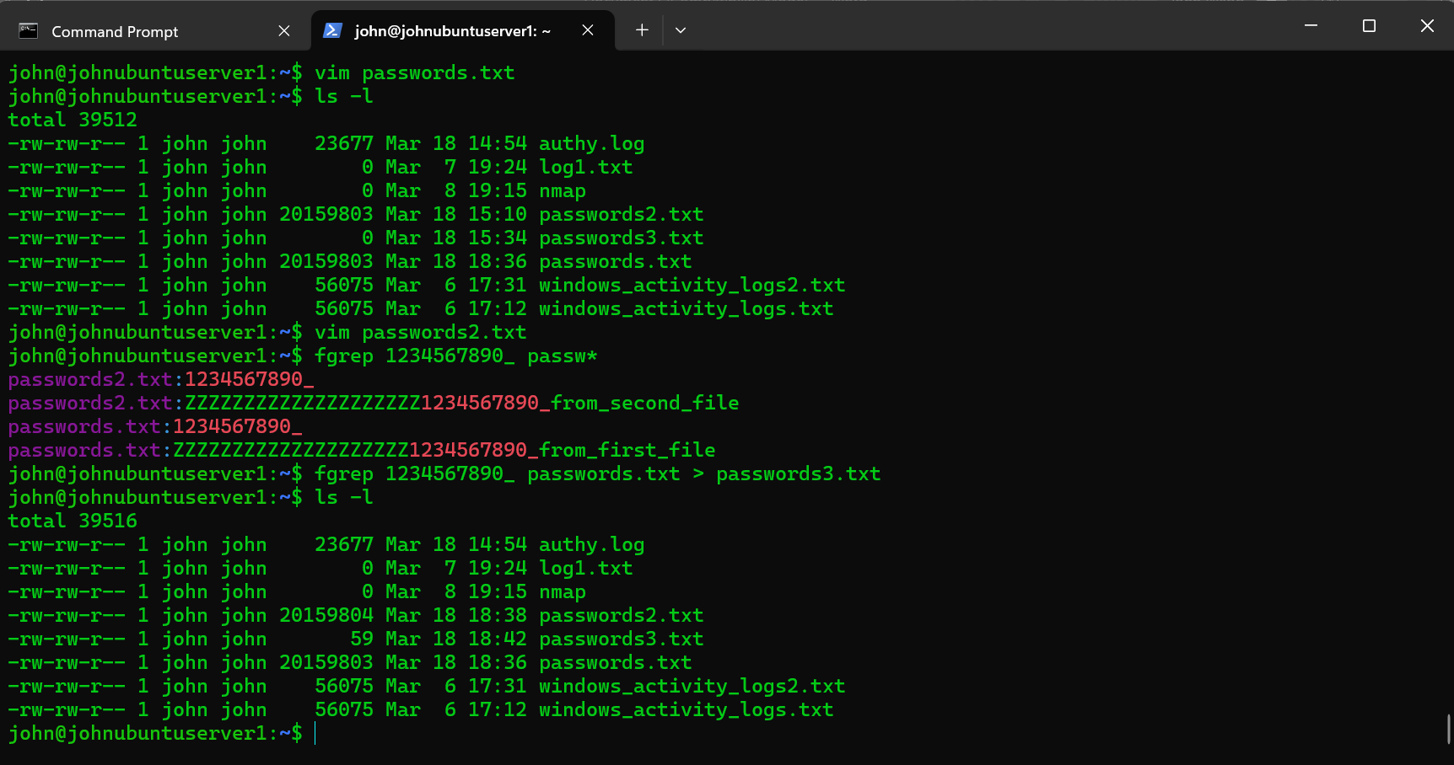

1. **fgrep:** This is a command-line utility that searches for a specific string of text in files. The "f" in **fgrep** stands for "fixed," meaning it searches for exact matches of the string specified.
2. **1234567890_:** This is the string being searched for. In this case, it's the sequence of characters "1234567890_".
3. **passwords.txt:** This is the file in which the search is being conducted. In this case, it's a file named "passwords.txt".
4. **>:** This is a redirection operator used to redirect the output of a command. In this case, it redirects the output of the **fgrep** command to a file.
5. **passwords3.txt:** This is the name of the file where the output of the **fgrep** command will be stored. In this case, it's a file named "passwords3.txt".

**Explanation of what happened:**

When the command is executed, **fgrep** searches through the contents of the file **passwords.txt** for the exact string "1234567890_". If any lines in the file contain this exact sequence of characters, **fgrep** will output those lines.

However, instead of displaying the output on the terminal, the **>** operator redirects the output to a new file named **passwords3.txt**. This means that any lines in **passwords.txt** containing "1234567890_" will be saved to the file **passwords3.txt**.

In summary, the command searched for occurrences of "1234567890_" within the file **passwords.txt** and saved any lines containing this exact sequence of characters to a new file named **passwords3.txt**. This is useful for filtering and extracting specific data from one file into another.

*Task #2*

cat passwords3.txt

• What did that do?

• Explain what just happened.

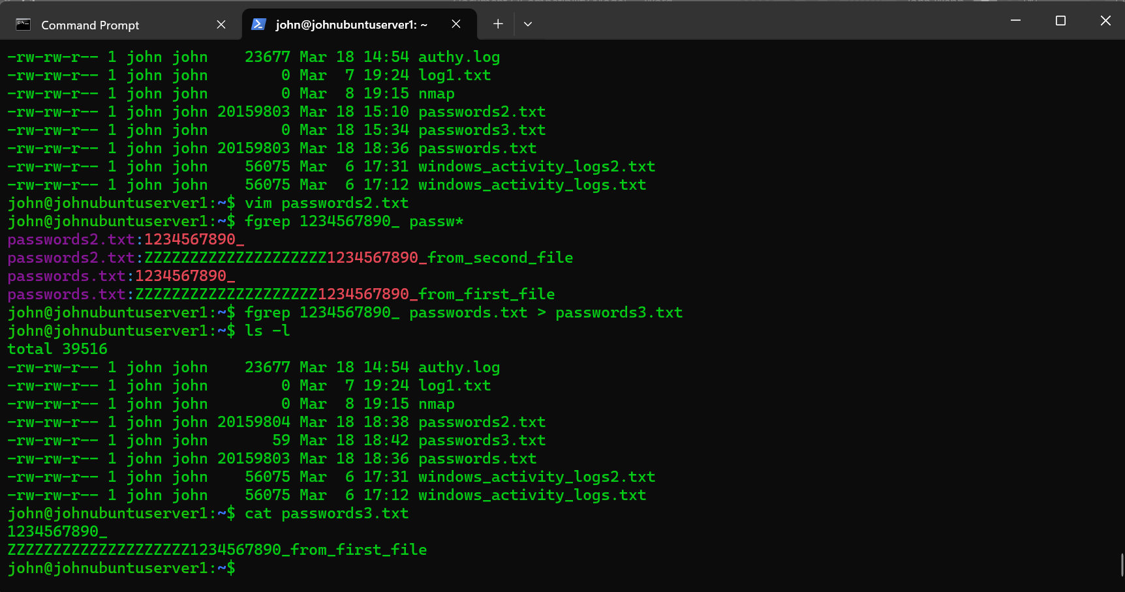

The **cat passwords3.txt** command is used to display the contents of the file named **passwords3.txt**.

**Explanation of what happened:**

When you execute **cat passwords3.txt**, it reads the contents of the file **passwords3.txt** and outputs it to the terminal. In this specific case, **passwords3.txt** was the file generated by the previous command **fgrep 1234567890_ passwords.txt > passwords3.txt**, which contained lines from **passwords.txt** that matched the string "1234567890_".

So, when you run **cat passwords3.txt**, you're essentially displaying the lines containing "1234567890_" that were extracted from **passwords.txt** and saved into **passwords3.txt**. This command is often used to quickly check the content of a file without opening it in an editor.

*Task #3*

fgrep -c 1234567890_ passw*

• What did that do?

• Explain what just happened.

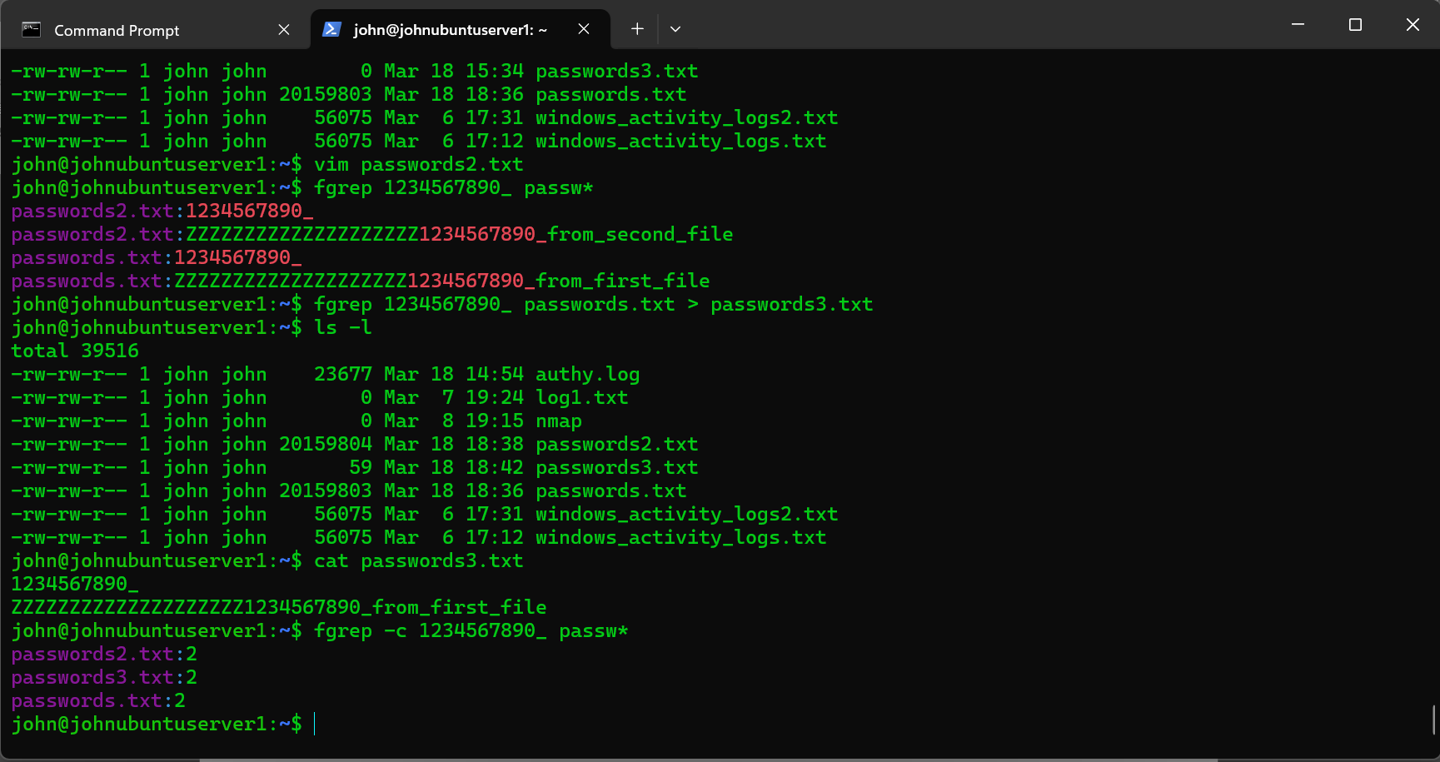

The command **fgrep -c 1234567890_ passw\*** was used. Let's break down what it does and explain the process:

1. **fgrep:** This is a command-line utility that searches for a specific string of text in files. The "f" in **fgrep** stands for "fixed," meaning it searches for exact matches of the string specified.
2. **-c:** This is an option used with **fgrep** to count the occurrences of the specified string instead of displaying the lines containing it.
3. **1234567890_:** This is the string being searched for. In this case, it's the sequence of characters "1234567890_".
4. **passw*:** This is a wildcard expression used to specify the file or files in which the search is conducted. The asterisk (*) is a wildcard character that matches any sequence of characters. So **passw\*** would match any files starting with "passw".

**Explanation of what happened:**

When the command is executed, **fgrep** searches through the contents of all files in the current directory that match the pattern **passw\*** for the exact string "1234567890_". Instead of displaying the lines containing this string, the **-c** option instructs **fgrep** to count the number of occurrences of the string across all the files.

So, the output of this command would be the total count of occurrences of "1234567890_" found in all files whose names start with "passw" in the current directory.

In summary, the command counted the occurrences of "1234567890_" within files whose names start with "passw" in the current directory, without displaying the actual lines containing the string.

*Task #5*

fgrep -w 1234567890_ passw*

• What did that do?

• Explain what just happened.

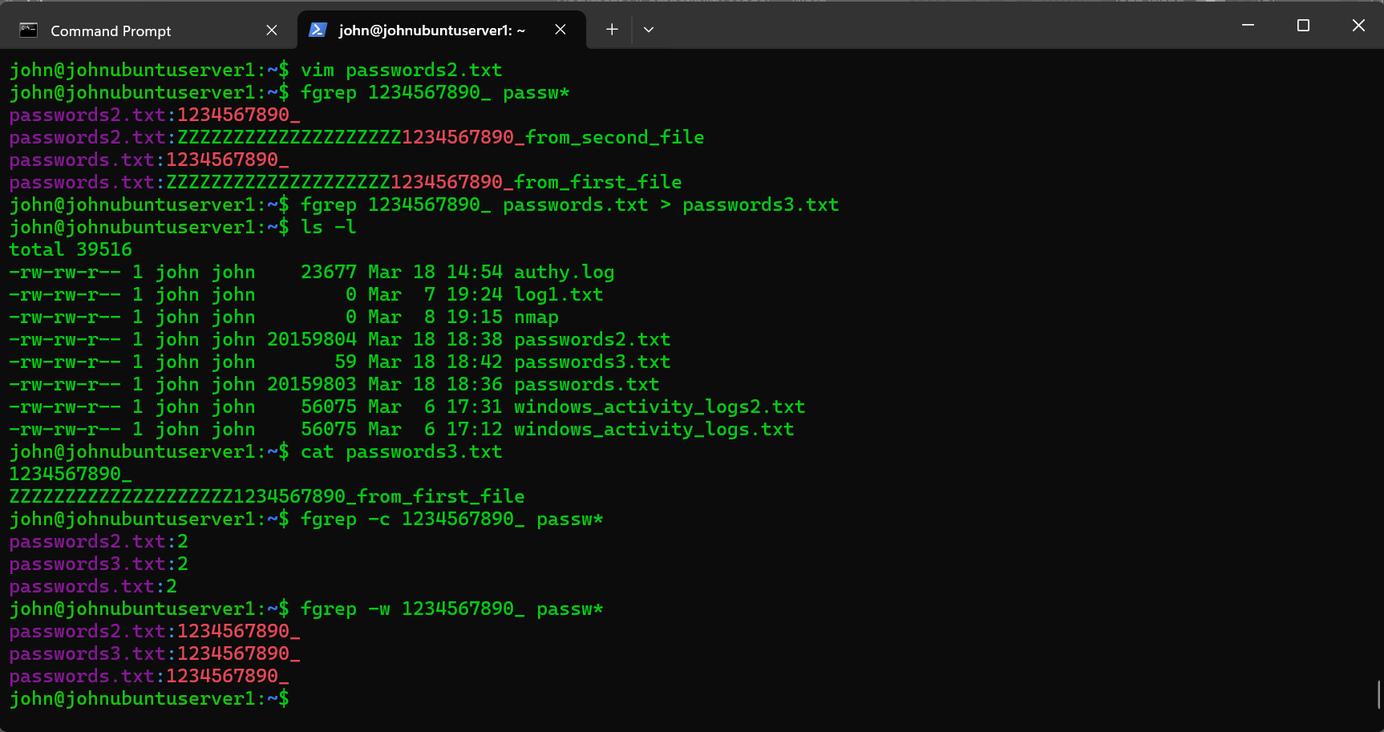

The command **fgrep -w 1234567890_ passw\*** was used. Let's break down what it does and explain the process:

1. **fgrep:** This is a command-line utility that searches for a specific string of text in files. The "f" in **fgrep** stands for "fixed," meaning it searches for exact matches of the string specified.
2. **-w:** This is an option used with **fgrep** to specify that the search should match whole words only. It ensures that the string being searched for is not part of a larger word.
3. **1234567890_:** This is the string being searched for. In this case, it's the sequence of characters "1234567890_".
4. **passw*:** This is a wildcard expression used to specify the file or files in which the search is conducted. The asterisk (*) is a wildcard character that matches any sequence of characters. So **passw\*** would match any files starting with "passw".

**Explanation of what happened:**

When the command is executed, **fgrep** searches through the contents of all files in the current directory that match the pattern **passw\*** for the exact string "1234567890_". However, the **-w** option ensures that the match is restricted to whole words only.

So, **fgrep** will only match instances of "1234567890_" that are standalone words in the files, and it won't match if this sequence of characters is part of a longer word.

In summary, the command searched for occurrences of the whole word "1234567890_" within files whose names start with "passw" in the current directory. It would not match if "1234567890_" was part of a longer word.

*Task #6*

fgrep -n 1234567890_ passw*

• What did that do?

• Explain what just happened.

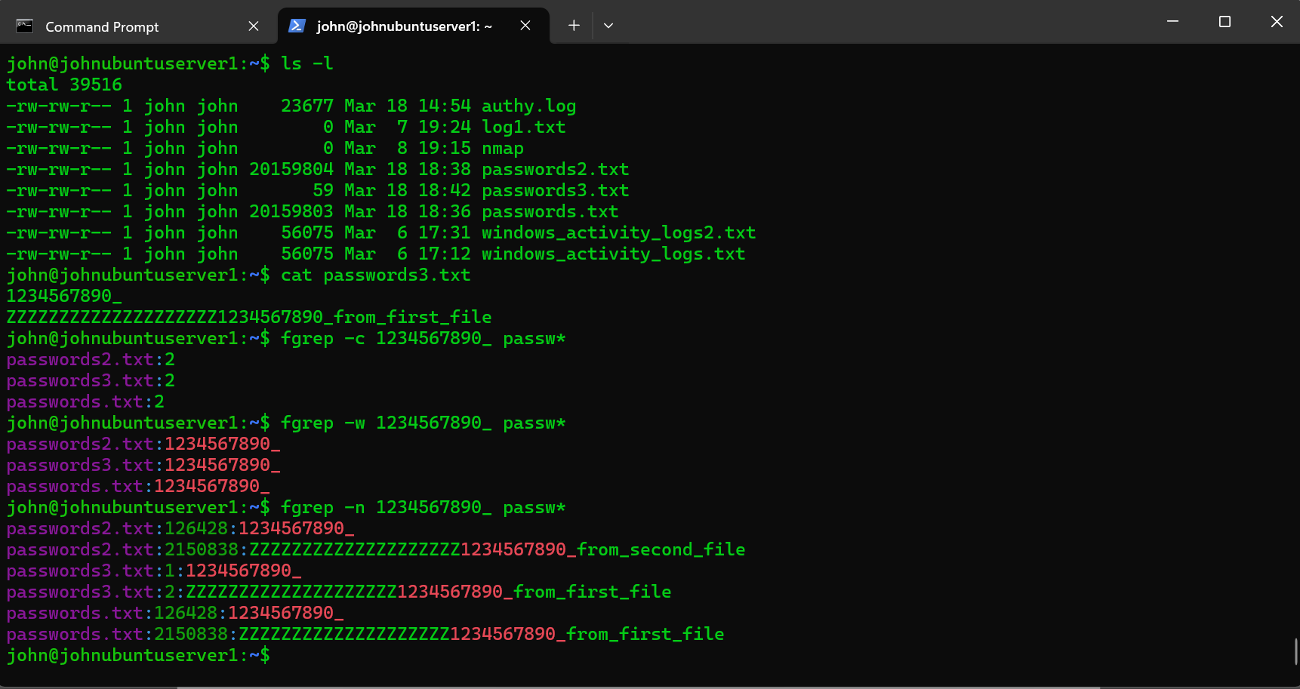

The command **fgrep -n 1234567890_ passw\*** was used. Let's break down what it does and explain the process:

1. **fgrep:** This is a command-line utility that searches for a specific string of text in files. The "f" in **fgrep** stands for "fixed," meaning it searches for exact matches of the string specified.
2. **-n:** This is an option used with **fgrep** to display the line numbers along with the lines containing the matched string. Each line in the output will be prefixed with the line number.
3. **1234567890_:** This is the string being searched for. In this case, it's the sequence of characters "1234567890_".
4. **passw*:** This is a wildcard expression used to specify the file or files in which the search is conducted. The asterisk (*) is a wildcard character that matches any sequence of characters. So **passw\*** would match any files starting with "passw".

**Explanation of what happened:**

When the command is executed, **fgrep** searches through the contents of all files in the current directory that match the pattern **passw\*** for the exact string "1234567890_".

Additionally, the **-n** option instructs **fgrep** to display the line numbers of the lines containing the matched string.

So, the output of this command would include the file name, line number, and the line content for each occurrence of "1234567890_" found in the files whose names start with "passw" in the current directory.

In summary, the command searched for occurrences of "1234567890_" within files whose names start with "passw" in the current directory and displayed the line numbers along with the lines containing the matched string.